**HUMAN SAFETY USING IMAGE PROCESSING SYSTEM**

**BY**

**SK. SHAHRUKH HOSSAIN SHISHIR**

**ID: 15502000915**

**AFSANA HOQUE TONNI**

**ID: 15502000961**

This Report Presented in Partial Fulfillment of the Requirements for

the Degree of Bachelor of Science in Computer Science and Engineering.

Supervised By

**MD. LITON HOSSAIN**

Assistant Professor

Department of ECE

**INSTITUTE OF SCIENCE AND TECHNOLOGY**

**DECLARATION**

We hereby declare that, this project has been done by us under the supervision of **MD. LITON HOSSAIN, Assistant Professor, Department of ECE** in **INSTITUTE OF SCIENCE AND TECHNOLOGY**. We also declare that neither this project nor any part of this project has been submitted elsewhere for award of any degree or diploma.

**Supervised by:**

Shape

**MD. LITON HOSSAIN**

Assistant Professor

Department of ECE

**INSTITUTE OF SCIENCE AND TECHNOLOGY**

**APPROVAL**

This Project titled **“HUMAN SAFETY USING IMAGE PROCESSING SYSTEM”**

submitted by

**SK. SHAHRUKH HOSSAIN SHISHIR**

**ID: 15502000915**

**AFSANA HOQUE TONNI**

**ID: 15502000961**

to the Department of Computer Science and Engineering, Institute of Science and Technology, have been accepted as satisfactory for the partial fulfillment of the requirements for the degree of B.Sc. in Computer Science and Engineering and approved as to its style and contents.

**Supervised by:**

Shape

**MD. LITON HOSSAIN**

Assistant Professor

Department of ECE

**INSTITUTE OF SCIENCE AND TECHNOLOGY**

**ACKNOWLEDGEMENT**

First, we express our heartiest thanks and gratitude to almighty Allah for His divine blessing makes us possible to complete this project successfully.

We feel grateful to MD. LITON HOSSAIN,Assistant Professor, Department of ECE, Institute of Science and Technology. DeepKnowledge & passionate interest of our supervisor in the field of Software Development influenced us to carry out this project. His endless endurance, scholastic guidance, continuous encouragement, constant and diligent supervision, constructive criticism, valuable advice, reading many inferior drafts and correcting them at all stage have made it possible to complete this project.

Finally, we must acknowledge with due respect the constant support and endurance of our parents.

**ABSTRACT**

The easiest way to separate each other's identity in the face. Face recognition is a personal identification system that uses the individual's personal characteristics to identify the person's identity. The human face recognition system is fundamentally in two stages, such as facial detection, where this process is performed very quickly in humans, beyond the conditions in which the objects are located at short distances, the next is the role, which identifies the person face. The stage is then developed as a model of replication and facial recognition models as well as developed by one of the many advanced research biometrics technologies and expertise. There are two types of methods that are now popular with advanced face detection patterns, such as eigen faces and fishing methods. For facial recognition, the eigenface system is based on face-level space reduction using Principal Component Analysis (PCA) for facial features. Using Eigen's face, the main purpose of using the PCA to detect facial identification (face space) was to detect the highest eigen value associated with the image. Human Face Recognition Using Image Processing of this project with face recognition. The requirements elements of this project are OpenCV and python. For this project we use some keywords such as face recognition, Eigen face, PCA, python, OpenCV. For the extension, there are a large number of applications from this facial recognition project, this project can be extended that different parts and sizes can be detected in different parts of the face.

**TABLE OF CONTENTS**

**CONTENTS PAGE**

|  |  |
| --- | --- |
| Approval | i |
| Declaration | ii |
| Acknowledgements | iii |
| Abstract | iv |
| Table of Contents | v-vi |
| List of Figures | vii |
| **CHAPTER 1: INTRODUCTION** | **01-04** |
| 1.1 Introduction | 01 |
| 1.2 Motivation | 01 |
| 1.3 Objectives | 02 |
| 1.4 Expected Outcome | 02-03 |
| 1.5 Report Layout | 03-04 |
| **CHAPTER 2: BACKGROUND** | **05-08** |
| 2.1 Introduction | 05 |
| 2.2 Literature Review | 05-06 |
| 2.3 Comparative Studies | 07 |
| 2.4 Scope of the Problem | 07 |
| 2.5 Challenges | 08 |
| **CHAPTER 3: RESEARCH METHODOLOGY** | **09-15** |
| 3.1 Introduction | 09 |
| 3.2 Research Methodology | 09-11 |
| 3.3 Data Flow Model | 12 |
| 3.4 Activity Diagram | 13 |
| 3.5 ER Diagram  3.6 Use Case Model | 14  15 |
| **CHAPTER 4: CONCLUSION AND FUTURE SCOPE** | **16-17** |
| 4.1 Discussion and Conclusion | 16 |
| 4.2 Scope for Further Developments | 17 |
|  |  |

**CHAPTER 1**

**INTRODUCTION**

* 1. **Introduction**

Recognition of human face is a part of biometrics field. Biometrics is a computer's ability to recognize a human through a unique physical feature. Face recognition provides the ability to identify humans with computer facial features. Today, biometrics is one of the fastest growing fields of advanced technology. Predictions which indicate a biometric explosion in the next century, for detection and unauthorized access and authentication on networks, databases and facilities.

Human face recognition using image processing is a process that takes a picture or a video of a human face and compares it to other images in a database. Composition, shape and ratio are compared when in face recognition steps. The distance between the contact, eye, nose, mouth, optical socket, comparisons compared to the face, nose and eye position.

* 1. **Motivation**

In the modern networked world, the need to maintain our information or physical assets is becoming increasingly important and increasingly difficult both. Crime rates in our countries like Bangladesh are increasing day by day. There is no automated system that can track the person's activity. If we are able to automatically detect the identity of the person's face, then we can easily find the criminal by recognizing the face which is saved in database. So, we decided to recognize a human face using the image processing technique. We are interested in this project after we went through a few papers in this region. The papers were published according to the system creation system and the system for creating accurate and reliable human face detection systems.

Text Box

As a result, we are very excited for a system development that recognizes the face and tracks a person's activity.

* 1. **Objectives**

Facial recognition is widely used due to its advantage. The benefits of the facial recognition system are that it is not interference, and it can be done even from a distant distance, even the person will be aware that he is scanning. Such things are needed in the case of banks or government offices etc. And it will make facial recognition systems better than other biometric strategies, so they wanted to be used for surveillance for criminals, suspected terrorists, or looking for missing children.

* To develop a facial recognition system.
* To find a face in a big database of faces. In this approach the system returns a possible face from the database.
* To use for identifying a person on the spot and use it for access in different place.

Human face recognition program, when using different images, the individual must be taken with different angles and different facial expressions. During verification and identification, the matter stood in front of the camera for a few seconds and then compared with the previous recorded image.

* 1. **Expected Outcome**

The use of face recognition for human identification is most beneficial for identification purposes, because it is easy to recognize someone's face, and because of the reason a mask can disguise using it. The environment is considered to be a speed motion and the camera is focused on the subject as well.

1. The system can be used to recognize someone face.
2. The system can be used in mini-marts, shopping center to view security of the customers to enhance the business.
3. The system can be installed at busy places like airport, railway station or bus station for detecting human faces. If there are any faces that appeared suspicious, the system might set an internal alarm.
4. The system can also be used for educational purpose such as an attendance system.
5. This system can be used for identification in criminal suspects during interrogation.
6. This system can help emotions related to improving the processing of emotional information-research people.

2

Facial recognition, when it is used in combination with another biometric methods, can improve verification with identification results dramatically.

* 1. **Report Layout**

**Chapter 1: Introduction**

In this chapter we have discussed about the introduction, motivation of the work, objectives and expected outcome of the research work and the report layout.

**Chapter 2: Background**

We discussed about the background circumstances of our work. We also delivered the literature review, comparative studies, scope of the problem and challenges of the system.

**Chapter 3: Research Methodology**

This chapter is all about the procedure used to build the system. This section has the methods and steps of the proposed system.

**Chapter 4: Conclusions and Future Scope**

This chapter contains the conclusion part and the ideas of implication of further study on this topic.

3

**CHAPTER 2**

**BACKGROUND**

**2.1 Introduction**

Human face recognition system is a desktop-based application and the developers have developed it by using OpenCV and python programming language. This application isused to detect or identify human faces and it is used for different purposes.

Facial recognition system human facial features like the mouth, nose, ear and eyes in a full-frontal face image. In our project, we use OpenCV for facial recognition. OpenCV (Open Source Computer Vision Library) which is open source and anyone can use this library for freely. OpenCV has C++, Python and Java interfaces which supports Windows, Linux, Mac OS, iOS and Android. OpenCV was designed for computational efficiency with a strong focus for real-time applications.

In our project when a human will come in front of the camera, it automatically captures the human full- frontal face with different features such as nose, eyes etc. Capture image will be stored in the database and when we will search the image it will be recognizedfrom the database.

**2.2 Literature Review**

Some algorithms and facial recognition techniques have been developed by past researchers. This section is discussed briefly.

The number of current facial recognition algorithms uses face presentations provided by incomplete statistical methods. In paper [1] Generally, these methods find a set of base images and describe faces as linear coordinates of those images. Principal component analysis (PCA) is one of the popular examples of such methods.

4

In paper [7] The foundation image obtained by the PCA depends solely on the pairwise relationship between pixels in the image database. An obligation to acknowledge the human face, in which pixels may include important information about high quality, it indicates that the image of this high-quality statistic can be more accurately identified by sensitivity. Paper [11] Independent Component Analysis (ICA), PCA is a generalization, which is one of the methods.

In paper [2] Eigenspace-based face detection is integrated into the most successful method for computational recognition of the face of digital images. Beginning with the eigen faces-algorithm, different eigenspace-based methods are supported to detect the face.

Paper [5] They vary mostly in the such kind of projection method used (standard, differential or kernel eigenspace) in the projection algorithm devoted, in the use ofnatural or differential images before/after projection, and in the similarity matchingstandard or classification method devoted. The aim of this paper is to represent an independent comparative study among some of the main eigenspace-based approaches.

We believe that conducting independent research is relevant because comparisons are usually performed by implementing the research method [10] which offers each method, which does not consider the whole uniform conditions for algorithms. Often, instead of comparing the approach, a contest takes place in the competition team skills.

In paper [7] In this study, theoretical aspects and simulators perform databases and Yale Faces database with databases, various classes and various images and FERETs, multiple classes in the class and various images with different images.

Paper [11] Do not use both PCA and ICA mouth class information. Linear DiscriminantAnalysis (LDA), which absorbs class information, finds an ancient way of presenting vector space. It manages the private face, but recognizes the face of the same person [4].

5

The LDA searches for vectors in underline space [9] which is the best disparity between classes. For all samples of all classes, two methods are defined.

**2.3 Comparative Studies**

Face recognition images are separated into two classes in Windows; Contains one face (background training). It is difficult because even though there is generality in the mouth, it can change in most cases according to age, skin color and facial expression. The problem is more complex by lighting conditions, image quality and geometries, and the possibility of partial confusion and disguise. Therefore, a standard face identifier will be able to detect any face availability under any set of light conditions by a sponsored source.

The purpose of the face detection can be broken in two steps. The first step is a classified objective that indicates whether the intentional image is binary value of yes or no as input and output, indicating that there is no face present in the picture. The second step is the purpose of the localization of the membrane, which aims to take an image as an importation and to take the position of the position of position like some cabbage box with the position of any face or face (x, y, width, height).

**2.4 Scope of The Problem**

The following table shows the approximate expected work to accomplish the necessary results.

|  |  |  |
| --- | --- | --- |
| **Time scheduling:** |  |  |
| Analysis | 2 | Month |
| Design of the system | 1 | Month |
| Coding | 3 Months |  |
| Testing and Implementing | 2 | Weeks |
| Total | 6 | Months and 14 days |

So, at this time we’ll complete the whole work.

6

**2.5 Challenges**

Our project "Human Face Recognition Using Image Processing" will be done to make it highly challenging for us for the face. For proper implementation, our human face must be properly identified and not only the face of the person but it also shows the information about the person.

**Requirement:**

The most important challenge was to recognize a face that was trained first. Then the identifying face shows the person's information correctly and for this reason we need the appropriate face features to identify.

**Time scheduling:**

It was a difficult challenge, because this is the main task that will be completed in our project. If we are unable to complete the time it will be a big hurdle for us. So, we will share our time and project work to complete the entire project to complete all the work.

**Poor Communication:**

In order to fulfill our project, we have encountered various problems and every time we discussed our problems with our supervisor. He has given the right decision to complete our project correctly.

**Skills for the Project:**

A project sometimes requires skills that require the project. So, we needed some skill and we achieved that skill to complete our project and we discussed all the issues and decided to do the right thing.

7

**CHAPTER 3**

**RESEARCH METHODOLOGY**

**3.1 Introduction**

The previous section illustrates various techniques and methods of identification and recognition of the face. Each category of process performs well in specific criteria and has difficulty as well. The precision and accuracy levels are still too far in the system. The following areas are offered visual observation for identity and recognition systems.

**3.2 Methodology**

A challenging task to provide a powerful system that needs situations in the most prevalent situations in the past. The pictures will be scanned by the scanner and stored in the database. Again, the images will be scanned and stored in the database. Now two pictures of the same candidate will be stored in the database.

The first step is to select the desired images from the database, then identify the face of each image in the next step to compare them. The next step is to identify that picture as the same candidate or not.

8

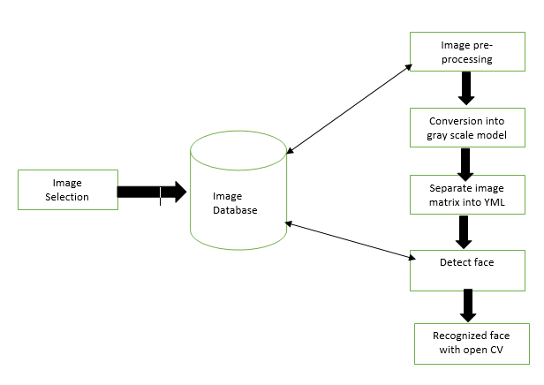

Figure 3.2: Structure of Human Face Recognition System with OpenCV

9

**The pseudo-code for PCA is as follows:**

Set image resolution parameter

Set PCA dimensionality parameter

Read training images ();

From training data matrix

Calculate PCA transformation matrix ();

Calculate feature vectors of all training images using matrix ();

Matrix= training feature vectors;

Read test faces ();

for (each test face do)

{

calculate the feature ();

consider the distances between test feature vector and all training vectors ();

depot the distances together with the training class labels ();

error + +;

// using the distance data, determine the person id of the most similar training vector

If (the found id is not equal to the id of the test image)

error count++;

else

{

output the correct recognition accuracy:

(1-(error count/total test image count)) *100

}

10

**3.3 Data Flow Model:**

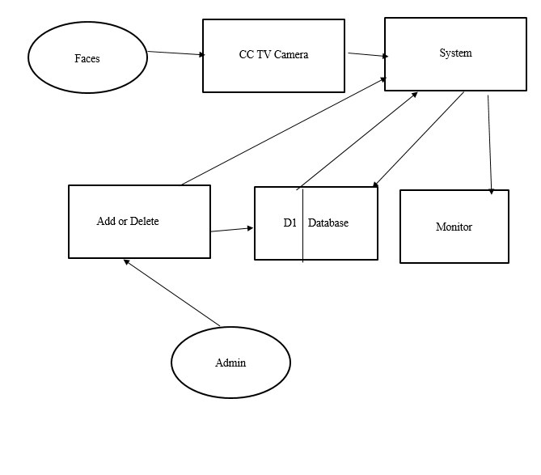

Figure 3.3: Data Flow Diagram for Face Recognition Using Image Processing

**Description:**

The data flow model actually shows the flow of data and its movements inside the system to database to system.

Here the faces taken by the cameras sending to the system. And the system can be used to add or delete new user data. And those data flow to the data base. Next time those data use to recognize the face and shows the id of the user in monitor if known.

11

**3.4 Activity Diagram**

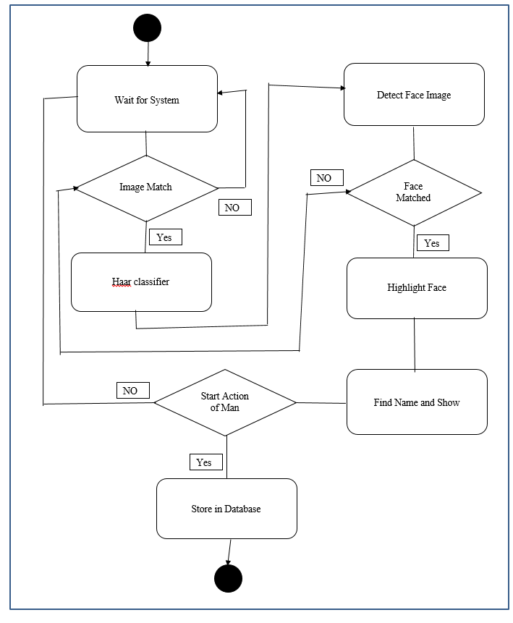

Figure 3.4: Activity Diagram for Face Recognition Using Image Processing

**Description:**

The activity diagram represents the insider working methodology of the system. When the system starts and it start collecting data it tries to match taken faces with the Database Using Haar Cascade classifier. Then the system highlights the face with proper tagline and start creating activity history for the face.

12

**3.5 ER Diagram**

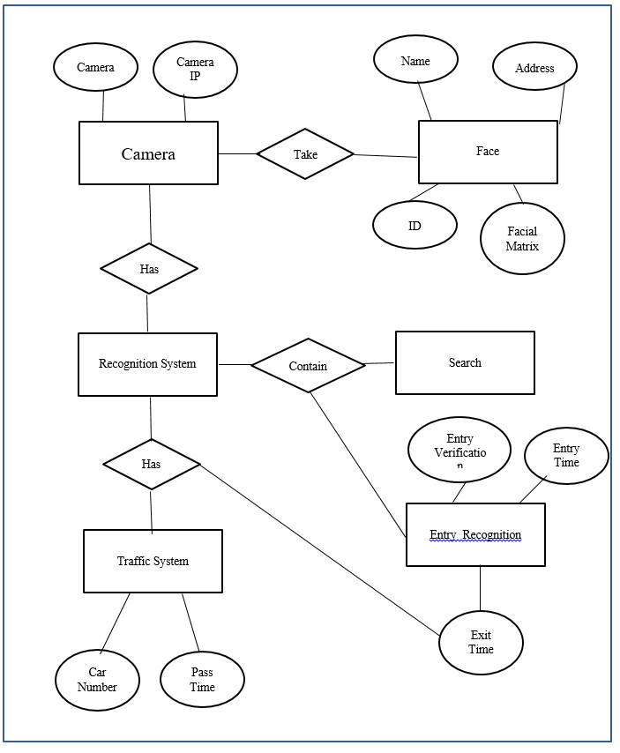

Figure 3.5: ER Diagram for Face Recognition Using Image Processing

**Description:**

The entity relationship diagram creates the link among the system and database.

13

**3.6 Use Case Model**

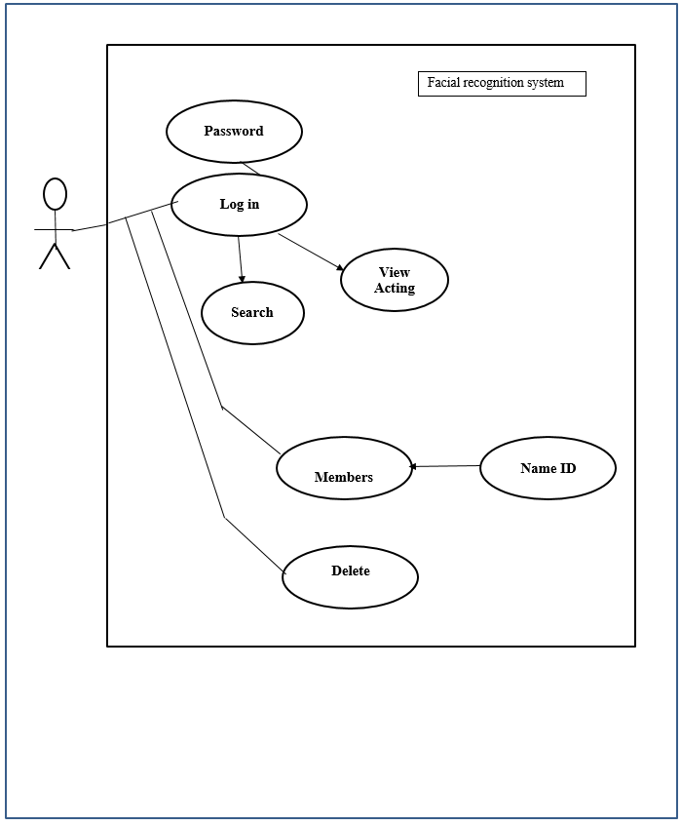

Figure 3.6: Use Case Model for Face Recognition Using Image Processing

**Description:**

Use case model is a representational view for user. A user means the admin can only use the system to add or delete user from the database. But the user must need to add his login id and login password to enter into the system.

14

**CHAPTER 4**

**CONCULASION AND FUTURE SCOPE**

**4.1 Discussion and Conclusion**

The system that was about to be implemented in this project was selected after extensive research, and successful test results ensured that the choices made by the developers were reliable. Due to a limited number of eigen faces used for PCA transformation, there was no recognition accuracy of approximately 89.6% in the human face recognition system. In this experimental test the system was tested under very strong conditions and it has been implemented that real-world performance is more accurate. Fully frontal view face recognition system displays virtually perfect accuracy and developers are not required to work more in this area. Face recognition system will be used more for security detection because they provide better performance on other protection systems. The human face recognition system is a step forward by progressive criminals, beneficial by world law enforcement and trial solutions. It is also necessary in Homeland Defense, to protect the identities of known or unknown people. It is adequate in safety and security at the airport and other transport terminals. Human face recognition systems, immigration and customs can improve staff performance. Financial services industry stands around security concepts. Human Face Recognition System, Financial Services can increase the security of the industry, reduce fraud and administrative costs to deal with forgotten passwords, can save time and money for both organizations. In addition, the biometric access control unit can protect the vault, the teller area and the safety deposit boxes to protect against theft. The use of biometrics can ensure that confidential confidentiality is maintained, especially when it detects identity theft as related to ATM terminals and card-no-current e-commerce transactions. It can analyze scenes from streaming or archived videos, "search" for common events, presence of certain cars, certain faces, etc. It is beneficial and can save significant time and money for people (such as checking a bank's security in a criminal investigation) who spend hours, days or weeks monitoring video streams.

15